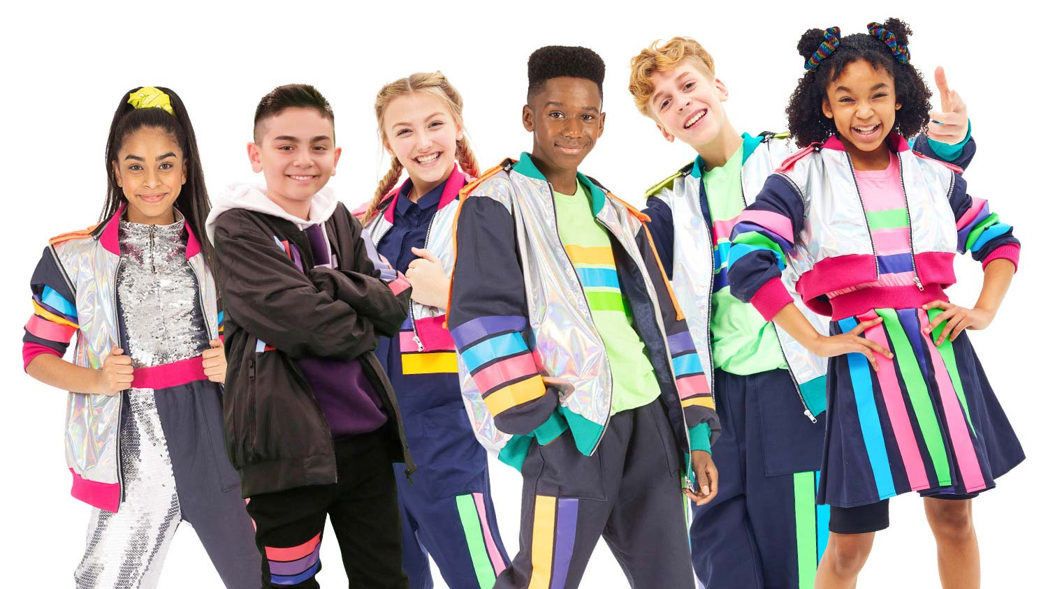
Safe and sound
I can't lift you up I can show you what you want
To see and take you where you want to be you
Could be my luck
Even if the sky is falling down
I know that we'll be safe and sound
We're safe and sound
I could lift you up
You know my river won't evaporate
This world we still appreciate
You could be my luck
Even in a hurricane of frowns
I know that we'll be safe and sound
Safe and sound
We're safe and sound
Safe and sound
We're safe and sound
Hold your ground
We're safe and sound
Safe and sound
I could show you love
In a tidal wave of mystery
You'll still be standing next to me
You could be my luck
Even if we're so far underground
I know that we'll be safe and sound
We're safe and sound
Safe and sound
We're safe and sound
Safe and sound
We're safe and sound
Hold your ground
We're safe and sound
Safe and sound
I could lift you up
I could show you what you wanna see
And take you where you wanna be
You could be my luck
Even if the sky is falling down
I know that we'll be safe and sound
I could lift you up
I could show you what you wanna see
And take you where you wanna be
You could be my luck
Even if the sky is falling down
I know that we'll be safe and sound
We're safe and sound
We're safe and sound
We're safe and sound
We're safe and sound
Safe and sound
We're safe and sound
Safe and sound
We're safe and sound
Hold your ground
We're safe and sound
Safe and sound
We're safe and sound

